Geometry
Conditionals Practice

Write each statement in if-then form. Underline the hypothesis and circle the conclusion. Also, write the converse, inverse, and contrapositive of the statement. Determine the validity of each statement.

1. There are 12 eggs in the carton if it is full.

Conditional: Valid?

Converse: Valid?

Inverse: Valid?

Contrapositive: Valid?

2. The square of odd numbers are odd.

Conditional: Valid?

Converse: Valid?

Inverse: Valid?

Contrapositive: Valid?

3. Coplanar points lie on the same plane.

Conditional: Valid?

Converse: Valid?

Inverse: Valid?

Contrapositive: Valid?
Circle the word that makes the concluding statement true.
4. The Oak Terrace apartment building does not allow dogs. Serena lives at Oak Terrace. So Serena (must, may, may not) keep a dog.
5. The Kolob Arch is the world’s widest natural arch. The world’s widest arch is in Zion National Park. So, the Kolob Arch (is, may be, is not) in Zion.
6. Zion National Park is in Utah. Jeremy spent a week in Utah. So, Jeremy (must have, may have, never) visited Zion National Park.
Determine if each conclusion is valid. Explain your reasoning.

7. If the sum of the measures of two angles is 90, then the two angles are complementary. Because m∠A + m∠C = 90, ∠A and ∠C are complementary.

Valid? Why?

8. If two adjacent angles form a right angle, then the two angles are complementary. Because ∠A and ∠C are complementary, ∠A and ∠C are adjacent.

Valid? Why?

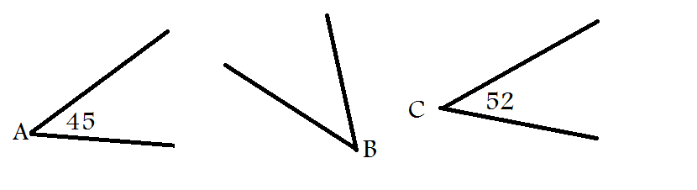
9. If ∠A and ∠C are acute angles, then any angle whose measure is between the measures of ∠A and ∠C is also acute. In the diagram below it is shown that m∠A < m∠B < m∠C, so ∠B must be acute.

Valid? Why?

Make a valid conclusion in the situation.

10. If the measure of an angle is 90⁰, then it is a right angle. m∠A = 90⁰.

11. If $x>12$, then $-x<-12$. The value of $x$ is 15.

12. If a book is a biography, then it is nonfiction. You are reading a biography.

13. If an angle is bisected, then it is cut into two equal halves. ∠ABC is bisected by $\overset{⃑}{BD}$.

14. If points are collinear, then they are also coplanar. Point A lies between points B and C.

